Practice 6.4: Inverse Functions-Cube Root and Cubic Equations
Algebra 2

Determine if the functions are inverses of each other.
Use composition to determine whether the functions are inverses.
Find $(f∘g)(x)$ and $(g∘f)(x)$.

1. $f\left(x\right)={(x-4)}^{3}$ $g\left(x\right)=\sqrt[3]{x}+4$

2. $f\left(x\right)=\sqrt[3]{x+2}$ $g\left(x\right)=x^{3}-2$

3. $f\left(x\right)=\frac{x^{3}}{2}$ $g\left(x\right)=\sqrt[3]{4x}$

Graph $y=x$. Graph the function and inverse function. Write the equation of the inverse function.
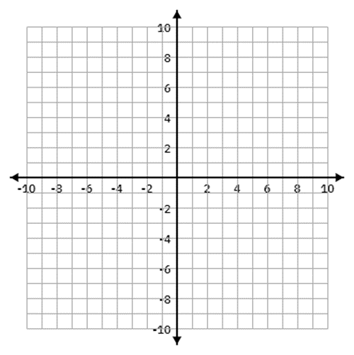

4. $y= - \sqrt[3]{x+2}+5$ 5. $f\left(x\right)= \sqrt[3]{x+1}-2$



6. $f\left(x\right)= {\left(x+7\right)}^{3}- 2$ 7.$f\left(x\right)={(x-1)}^{3}+2$


8. $y={(x+2)}^{3}+5$ 9. If $f(6)=7$, what would be one point on $f^{-1}(x)$?

10. If $f(4)=-2$, what would be one point on $f^{-1}(x)$?

